#2. Write a R program to print the numbers from 1 to 100 and print "Fizz" for multiples of 3, print "Buzz" for multiples of 5, and print "FizzBuzz" for multiples of both
##PROGRAM
for (n in 1:100) {
if (n %% 3 == 0 & n %% 5 == 0) {print("FizzBuzz")}
else if (n %% 3 == 0) {print("Fizz")}
else if (n %% 5 == 0) {print("Buzz")}
else print(n)

##OUTPUT
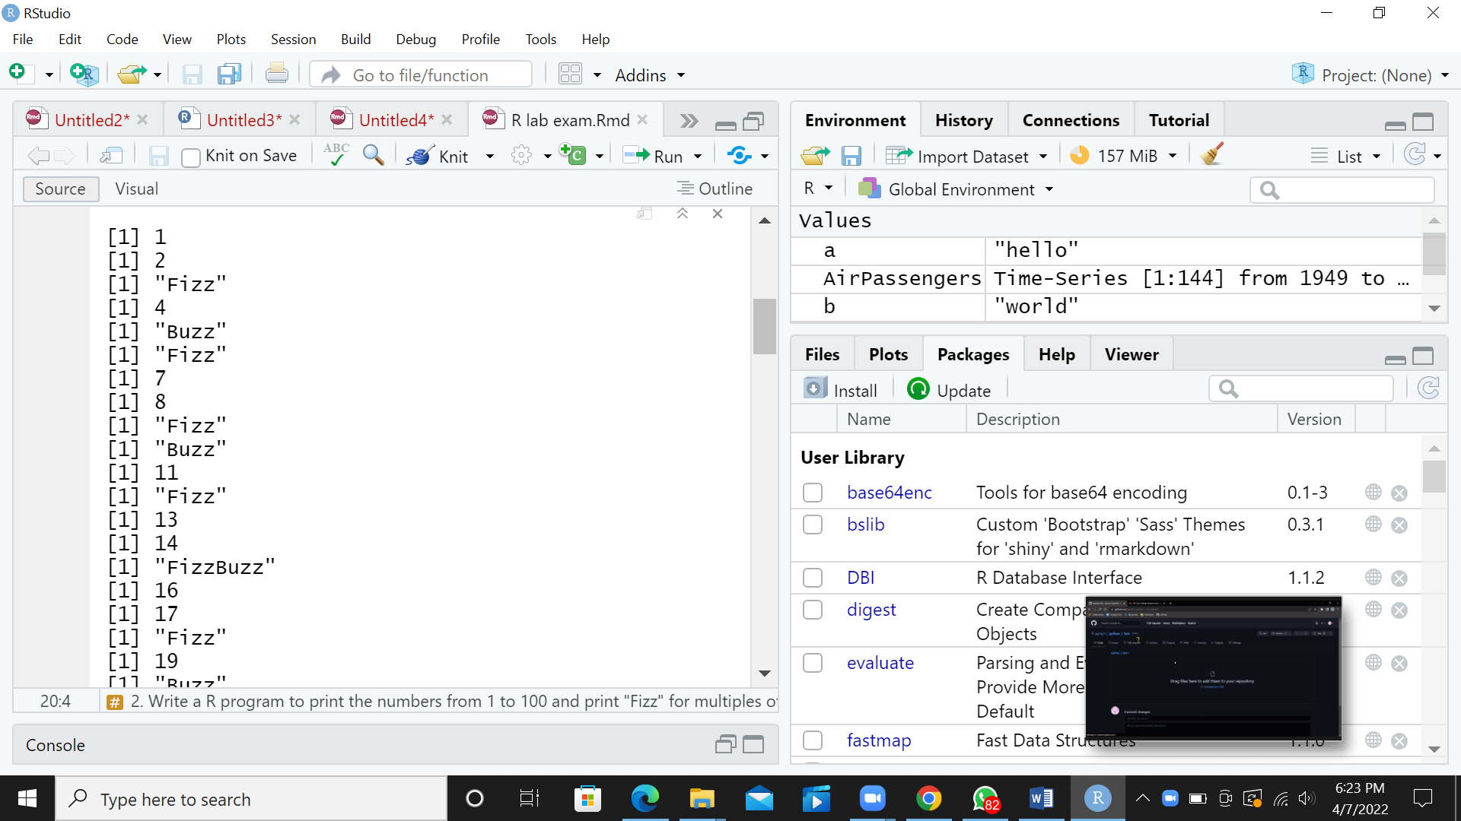
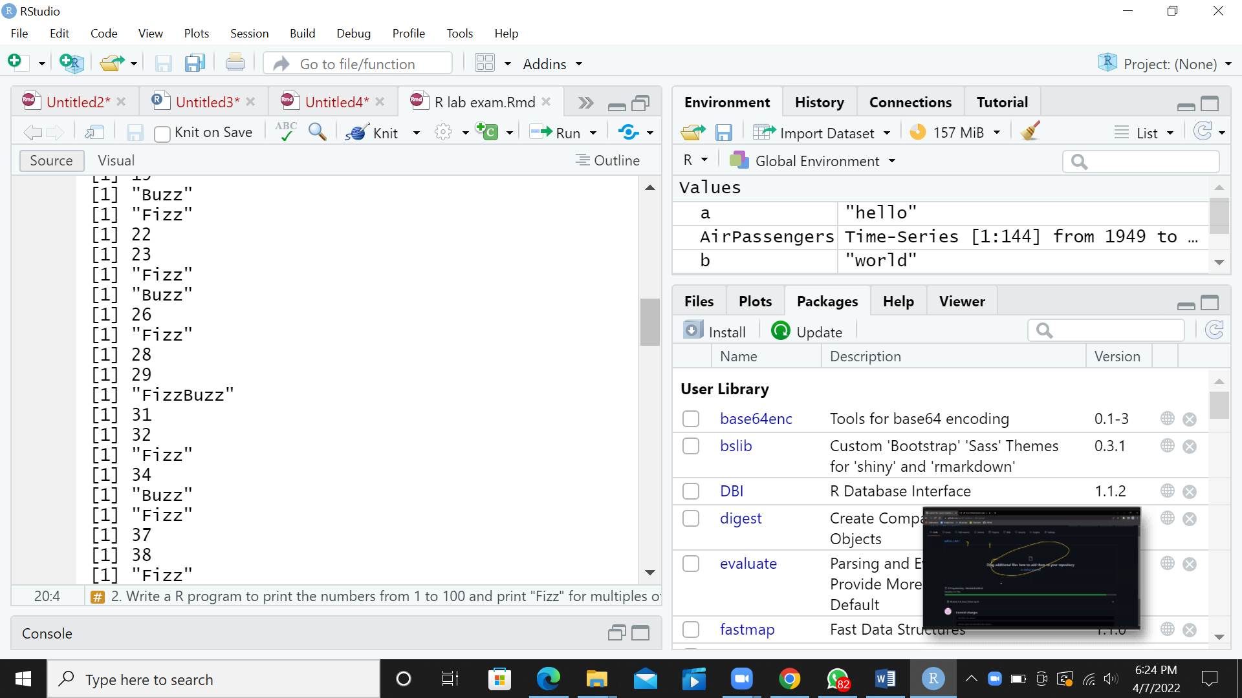
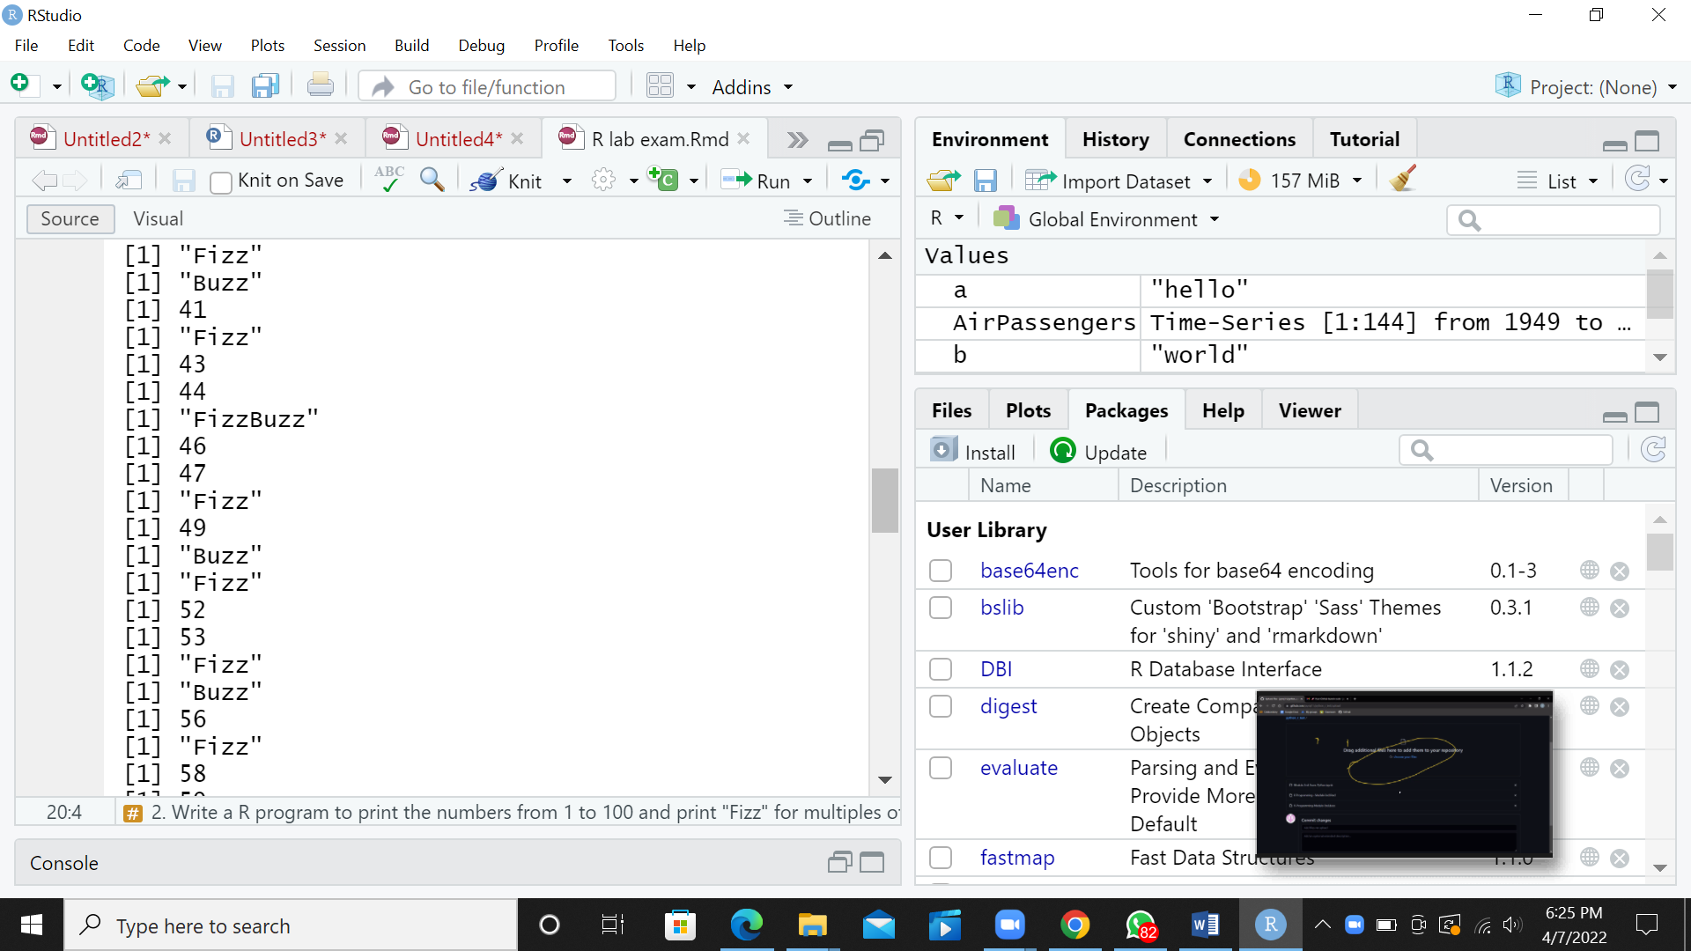
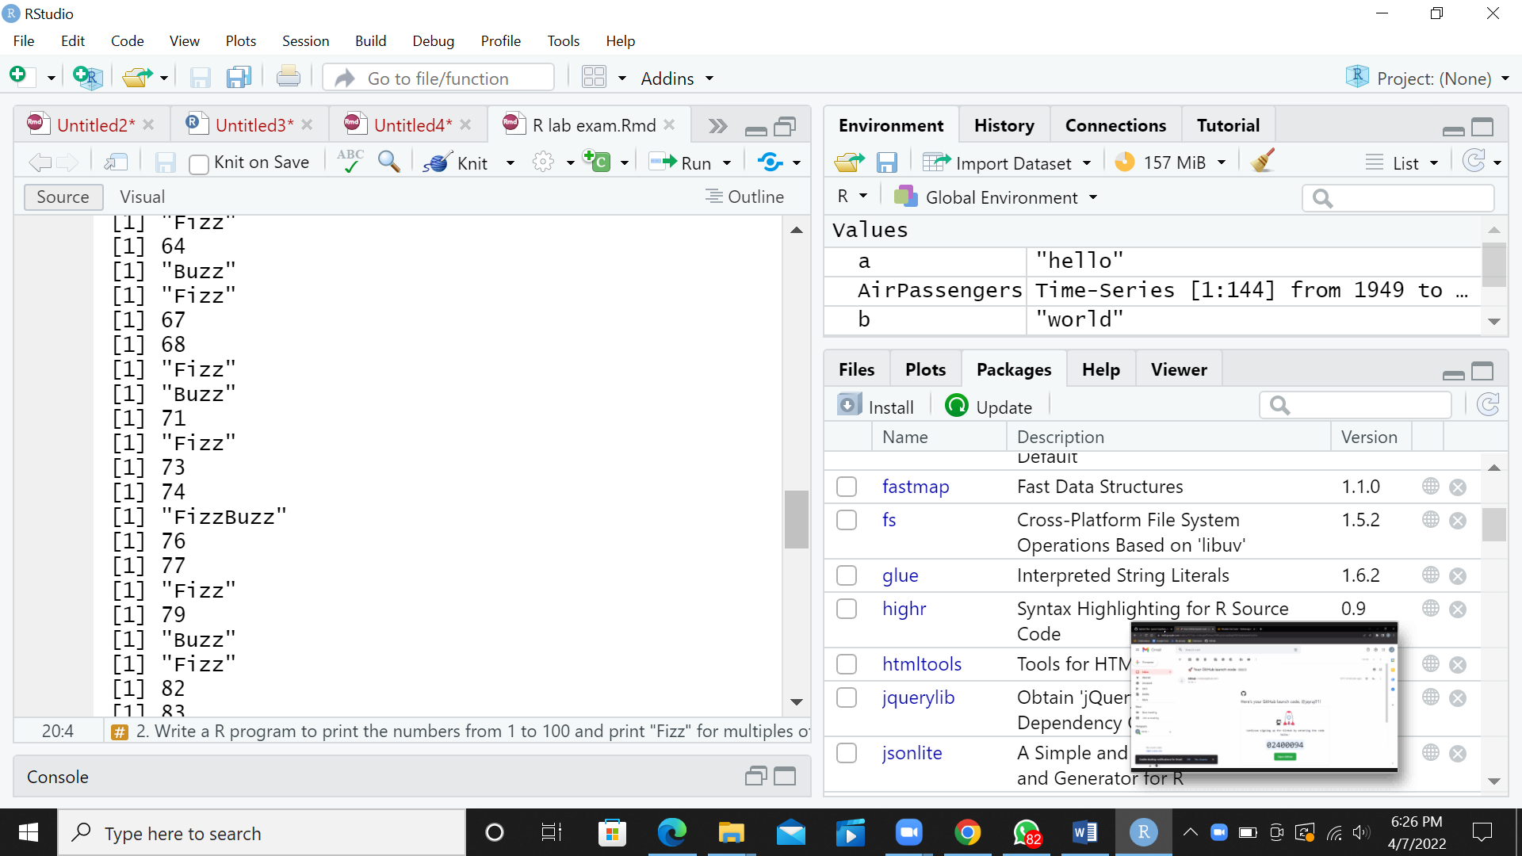
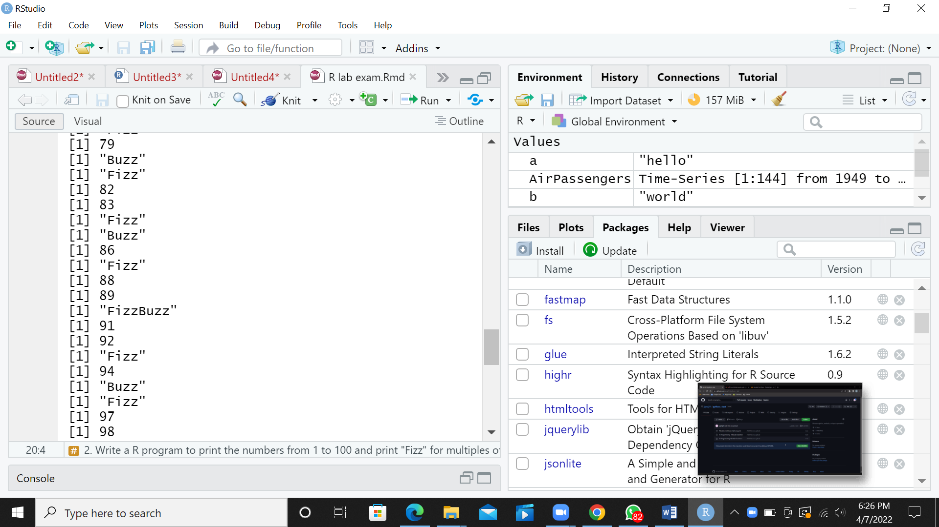

#1. Write a R program to create a sequence of numbers from 20 to 50 and find the mean of numbers from 20 to 60 and sum of numbers from 51 to 91.
##PROGRAM
print("seq of no. from 20 to 50:")
print(seq(20,50))
print("mean of no. from 20 to 60:")
print(mean(20:60))
print("sum of no. from 51 to 91:")
print(sum(51:91))

##OUTPUT
